Customer Shopping Behaviour Analysis

Prepared by: Afifah Khatoon
Date: June 2026
📌 Table of Contents
1. Project Overview
2. Tools Used
3. Project Objectives
4. Dataset Information
5. Methodology
6. Data Cleaning & Feature Engineering (Python)
7. Exploratory Data Analysis (Python)
8. Data Analysis using SQL
9. Data Visualization (Power BI)
10. Business Insights
11. Conclusion

📖 Project Overview
This project analyses customer shopping behaviour to understand purchasing patterns, customer preferences, and sales trends. The analysis is performed using Python for data cleaning and exploratory data analysis, SQL for querying, and Power BI for dashboard creation. The findings provide valuable business insights that support data-driven decision-making.

🛠️ Tools Used
- Python
- Jupyter Notebook
- Pandas
- NumPy
- Matplotlib
- Seaborn
- SQL
- Power BI
- Microsoft Excel
- GitHub

🎯 Project Objectives
- Understand customer shopping behavior.
- Perform data cleaning and preprocessing.
- Create meaningful features for analysis.
- Explore purchasing patterns.
- Analyse customer demographics.
- Identify sales trends.
- Generate business insights.
- Build an interactive Power BI dashboard.

📂 Dataset Information
- Dataset Name: Customer Shopping Behaviour Dataset
- Dataset link : https://github.com/afifahkhatoon61-beep/my-certificates-projects/blob/main/customer_shopping_behavior.csv

Customer Shopping Behaviour Analysis
- Import Libraries:-

- Load the Dataset:-

- Explore the Dataset:-
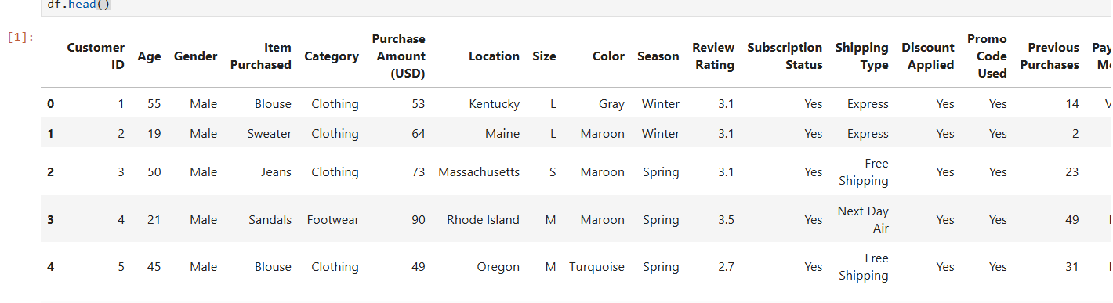

4. Dataset Overview:-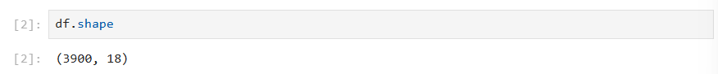

5. Dataset Structure & Data Types:-
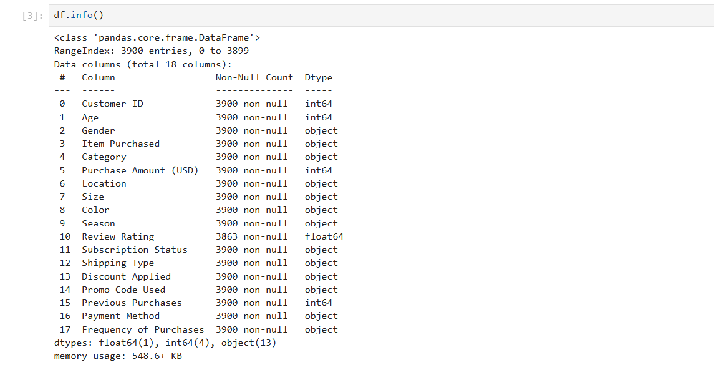

6.Missing Value Check:-
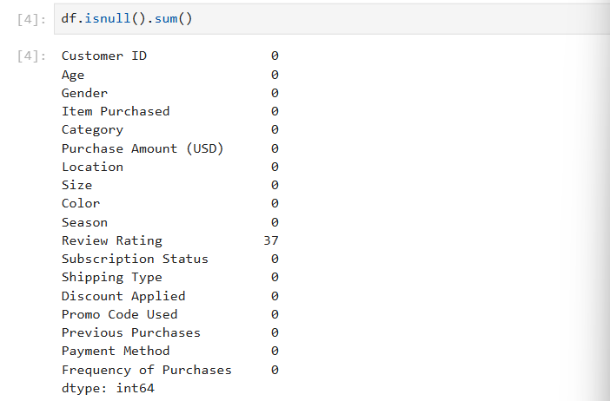
7. Statistical Summary of Numeric Columns:- 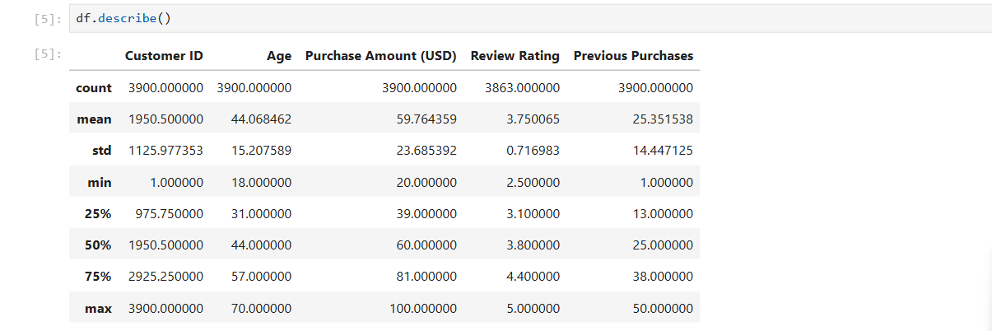

8. Data Cleaning — Standardizing Column Names:- 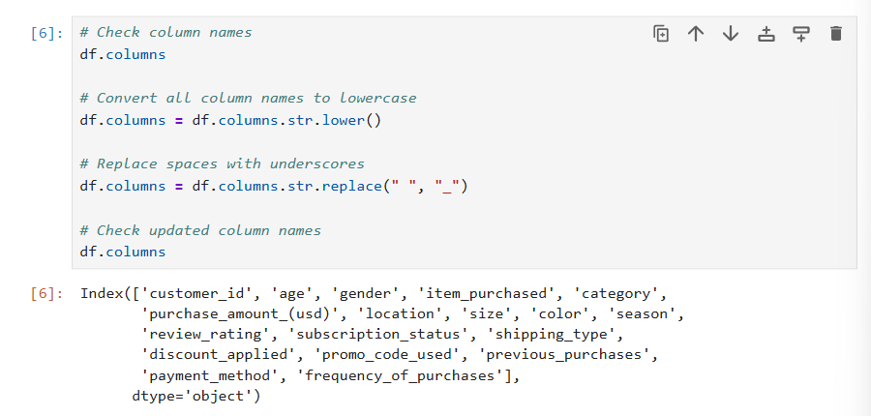

9. Feature Engineering — Creating Age Groups:-
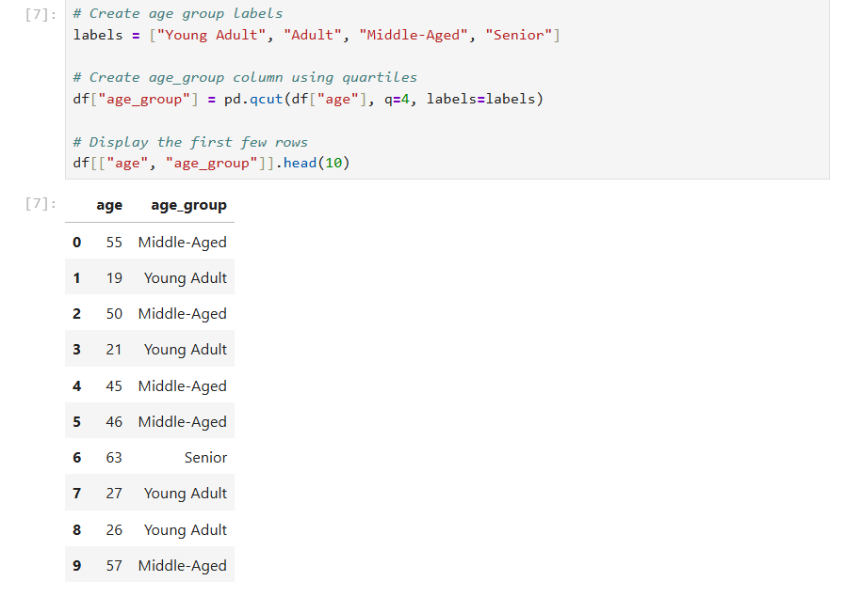

10.Feature Engineering – Create Purchase Frequency in Days:-

This section converts the categorical purchase frequency into numerical values (days) to make the data suitable for analysis and visualization.

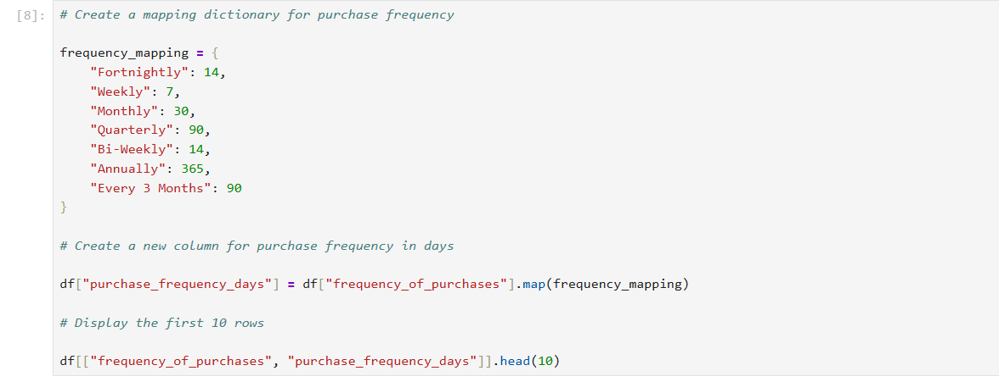
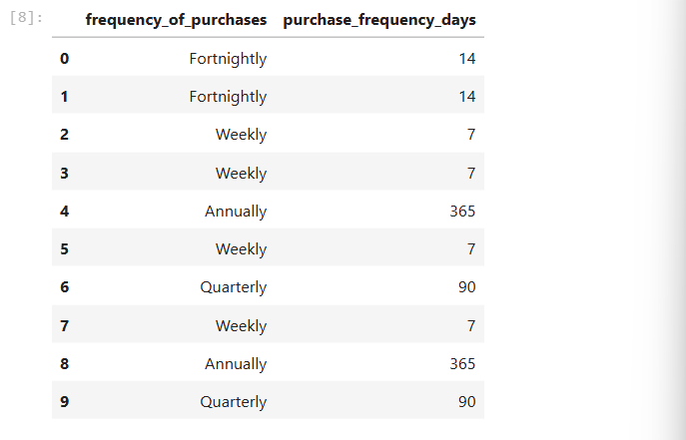

11.Data Exploration – View Discount and Promo Code Columns:-
This section examines the discount_applied and promo_code_used columns to understand how discounts and promotional codes are being used by customers.
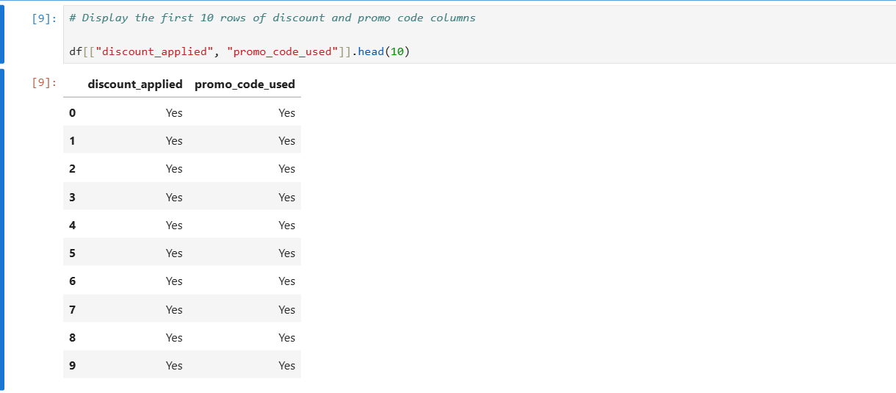

.12.Data Validation – Compare Discount Applied and Promo Code Used:-
This section verifies whether the discount_applied and promo_code_used columns contain identical values across all records. The .all() function returns True if every row matches; otherwise, it returns False.`

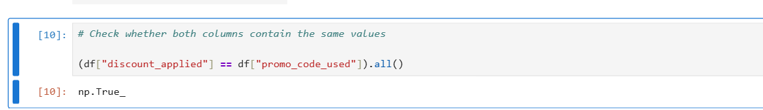

- Data Cleaning – Remove Redundant Column:-
This section removes the promo_code_used column because it contains the same information as discount_applied. Keeping duplicate information is unnecessary and can make the dataset redundant.
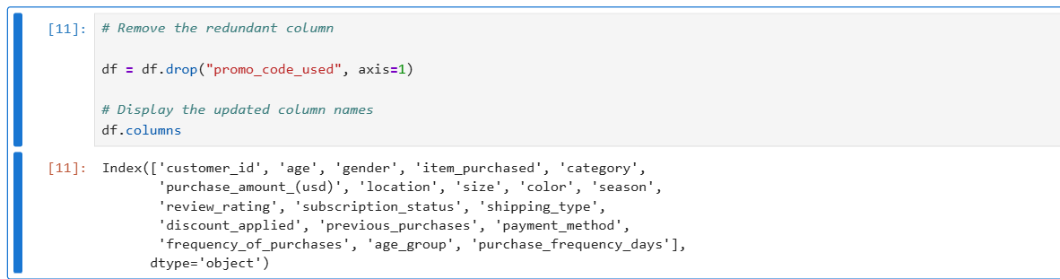

Data analysis by using SQL:-
1. Gender-Based Revenue Contribution:-
Explanation: Analyses the total sales volume generated by male vs. female shoppers to understand the dominant purchasing demographic.

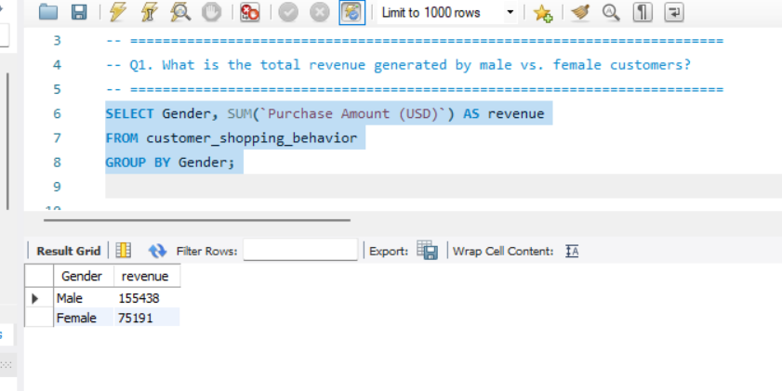
2. Discount Utilization vs. High-Value Purchases:-
Explanation: Identifies premium customers who utilize promotional discounts but still maintain a transaction value higher than the overall business average.

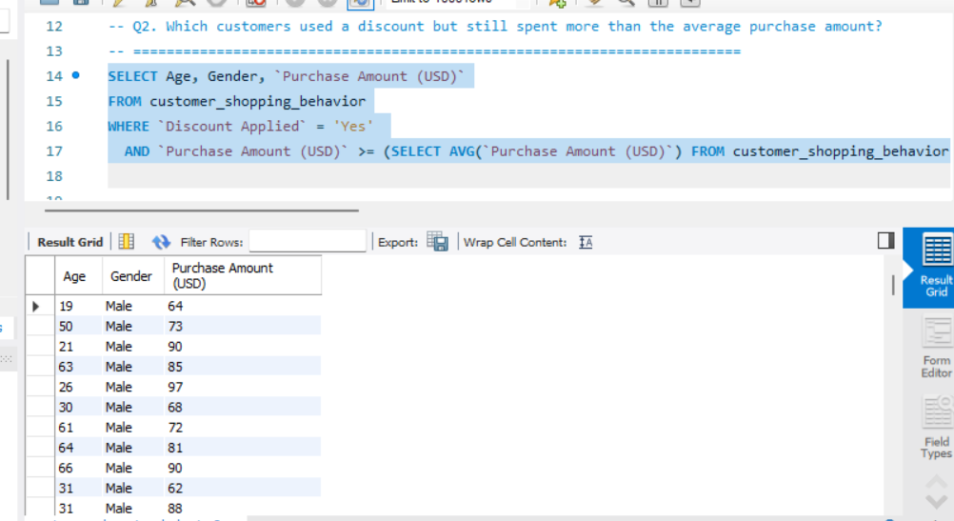

3. Top 5 Products by Customer Satisfaction:-
Explanation: Showcases the highest-rated inventory items based on average review scores to highlight product quality and customer preference.

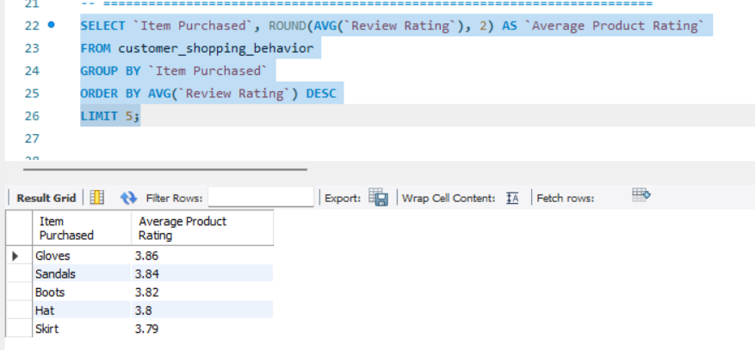

4. Logistics Performance & Average Order Value (AOV):-
Explanation: Compares the transactional value of Standard vs. Express shipping to determine if faster delivery options correlate with higher order values.

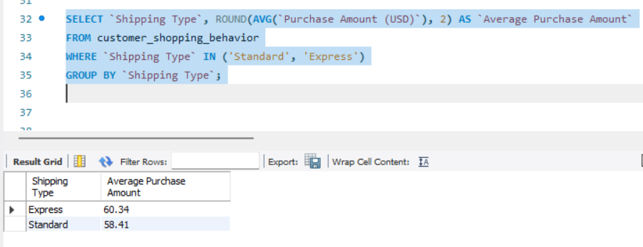
5.Subscription Program ROI & Loyalty Spends:-
Explanation: Evaluates the effectiveness of the subscription model by comparing the overall customer count, average ticket size, and total revenue between members and non-members.
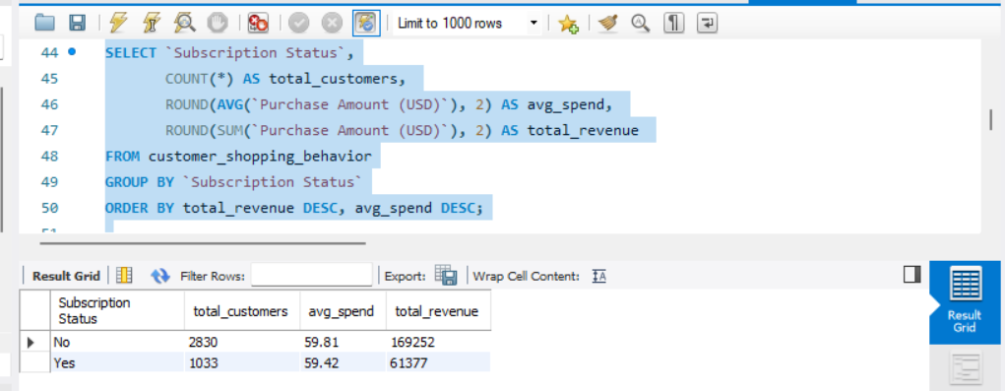

6. Highest Discount Rates by Product:-
Explanation: Measures the percentage of promotional sales per product to pinpoint which specific items rely heavily on discounts to drive conversions.
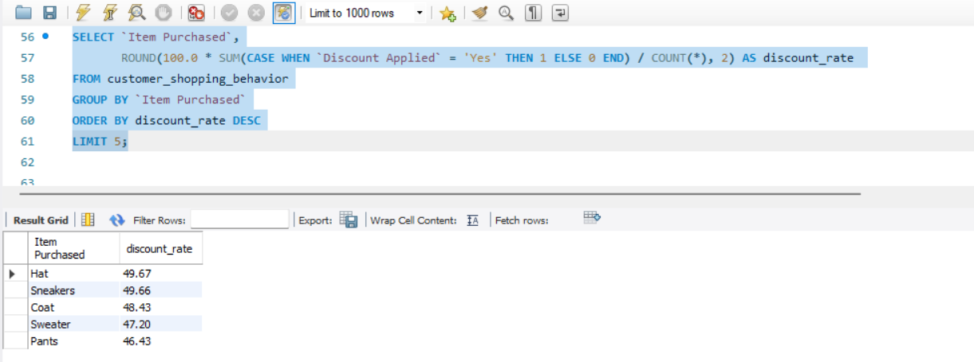
7.Customer Segmentation:-
Explanation: Classifies the consumer base into distinct cohorts based on their purchase history to measure customer retention and brand equity.

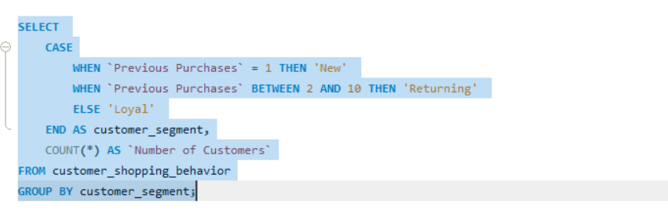

8. Category Top Performers:-
Explanation: Conducts an in-depth category breakdown to isolate and rank the three most frequently ordered items in each product sector.

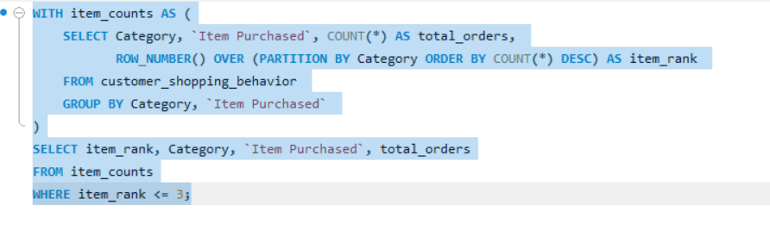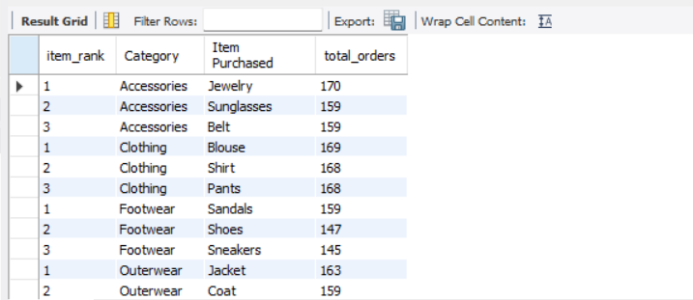

9.High-Frequency Buyer Subscription Conversion:-
Explanation: Analyses whether repeat buyers (customers with more than 5 historical orders) show a higher propensity to convert into premium subscribers.

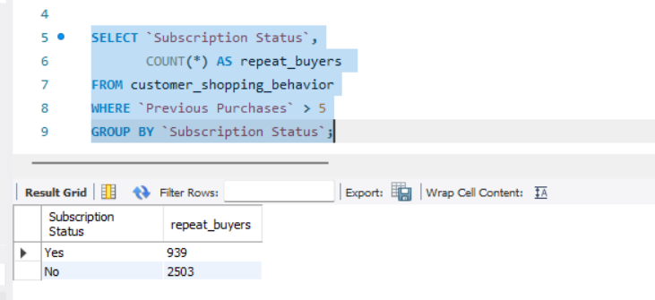

10. Demographic Spends & Age Group Revenue Distribution:-
Explanation: Segments the customer base into age brackets to identify which biological age demographics generate the maximum revenue for the business.
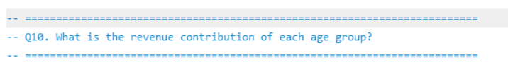
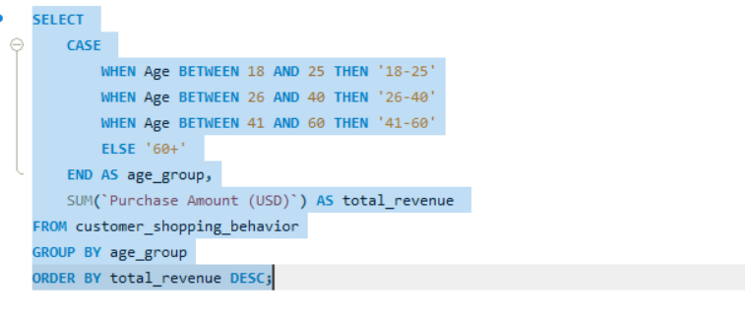
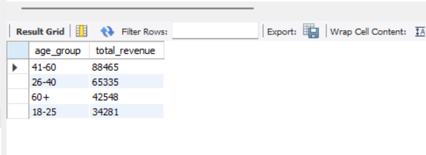

Data Visualization using Power BI:-

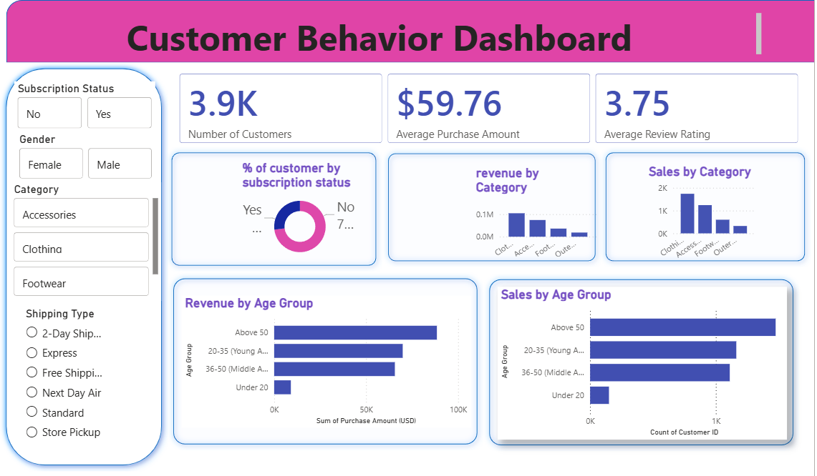

Business Insights:-
- Age-Driven Revenue Contribution — Customers aged above 50 generate the highest revenue and sales volume, followed closely by the 20–35 (Young Adult) segment, while customers under 20 contribute minimally. Marketing and loyalty programs should prioritize these high-value age groups.
- Category Performance — Clothing and Accessories are the top-performing categories in terms of both revenue and sales volume, while Footwear and Outerwear lag significantly behind. Inventory planning and promotional campaigns should focus on the strongest categories to maximize returns.
- Subscription Status Impact — A majority of customers hold an active subscription status, indicating strong potential for repeat purchases and customer loyalty. Targeted offers or incentives could be used to convert non-subscribed customers into subscribers.
- Customer Satisfaction Levels — The average review rating stands at 3.75 out of 5, indicating moderate customer satisfaction with room for improvement. Businesses should investigate lower-rated categories or products to identify areas for quality or service enhancement.
- Average Order Value — The average purchase amount per customer is $59.76. Implementing bundling, cross-selling, or upselling strategies could help increase the average order value and overall revenue per customer.

Conclusion:-
This project analysed customer purchase behavior across 3,900 records using SQL for data extraction and querying, Python (Pandas) for data cleaning, feature engineering, and exploratory analysis, and Power BI for building an interactive dashboard to visualize key metrics. The analysis revealed that customers aged above 50 contribute the highest revenue, Clothing is the top-performing category, and the average purchase amount stands at $59.76 with an average review rating of 3.75. These insights can help businesses optimize marketing strategies, target high-value customer segments, and improve product category performance.

Thank You,

